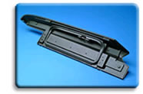
  Automotive Exteriors
  OEM Approvals

Grades of DEXFLEX® TPO, SEQUEL® engineered polyolefins, and INDURE® polyolefin alloys have been approved to OEM specifications by North American, Asian, and European carmakers. For a current list of the specifications to which specific materials are approved, click on the appropriate image below. Note that in some cases, a specific version of the listed grade (such as a black, natural, or UV-stabilized formulation) may be the approved material.
